**Promoting Security and Transparency in Online Auctions using Blockchain**

**Kamau, Edinah Nyambura**

**145491**

**Kyalo, Felicia Mutheu**

**145602**

**ICS 3C**

**Supervisor Name**

**Dr. Dickson Owuor**

**Submitted in Partial Fulfilment of the Requirements of the Bachelor of Science in Informatics and Computer Science at Strathmore University**

**School of Computing and Engineering Sciences**

**Strathmore University**

**Nairobi, Kenya**

**July 2023**

**Declaration and Approval**

We declare that this work has not been previously submitted and approved for the award of a degree by this or any other University. To the best of our knowledge and belief, the research proposal contains no material previously published or written by another person except where due reference is made in the research proposal itself.

Student Name: Kamau, Edinah Nyambura

Admission Number: 145491

Student Signature: _________________________ Date: ________________________

Student Name: Kyalo, Felicia Mutheu

Admission Number: 145602

Student Signature: _________________________ Date: ________________________

The Proposal of **Kamau, Edinah Nyambura** and **Kyalo, Felicia Mutheu** has been reviewed and approved by **Dr. Dickson Owuor**

Supervisor Signature: _________________________ Date: ________________________

**Abstract**

Electronic communication is expanding quickly right now, and many new applications are following suit. Nevertheless, the emergence of blockchain technology has introduced an amazing change across various sectors like business and banking. This aided numerous enterprise in turning a profit in their corresponding industries. Online auctioning applications are one of the numerous electronic communication applications that are now receiving a lot of positive feedback from users. By employing smart contracts to automate the bidding, verification, and settlement processes, the system reduces the need for intermediaries and boosts efficiency in operations. Every participant can verify the authenticity of auction listings, bids, and final outcomes, establishing confidence and trust among buyers and sellers. Additionally, the system does away with the need for third-party intermediaries creating buyers’ anonymity. Many of the drawbacks of traditional auctions, such as physical location, timing, travel requirements, a limit on the number of bidders, etc., have been eliminated by this online format. In our auction system, we've introduced blockchain and smart contracts as revolutionary technologies that have drawn interest from a wide range of industries. The security of payment gateways will be strengthened thanks to this technology. The system is fully secure thanks to these technologies, which provide the highest level of security. Our model's goal is to make it possible for anyone to run their own auctions or take part in the auction anytime, anywhere.

# Table of Contents

Table of Contents iv

List of Figures vi

Chapter 1: Introduction 1

1.1 Background 1

1.2 Problem Statement 2

1.3 Objectives 2

1.3.1 General Objective 2

1.3.2 Specific Objectives 2

1.4 Research Questions 2

1.5 Justification 3

1.6 Scope and Limitations 3

Chapter 2: Literature Review 5

2.1 Introduction 5

2.2 Current State of Online Auctions using Blockchain Technology 5

2.3 Challenges Facing the Current State of Online Auctions using Blockchain Technology 5

2.4 Related Works 5

2.4.1 Codex Protocol 5

2.4.2 SuperRare 6

2.4.3 OpenSea 6

2.5 Gaps in Related Works 6

2.6 Conceptual Frameworks 7

Chapter 3: Methodology 8

3.1 Introduction 8

3.2 System Development Methodology 8

3.2.1 Requirements Gathering 9

3.2.2 System Design 9

3.2.3 System Development 9

3.2.4 Testing 9

3.2.5 Deployment 9

3.2.6 Review 10

3.3 System Analysis 10

3.3.1 Use CASE Diagram 10

3.3.2 Sequence Diagram 10

3.3.3 ERD Diagram 10

3.3.4 Class Diagram 10

3.3.5 Activity Diagram 11

3.4 System Deliverables 11

3.4.1 System Proposal 11

3.4.2 Administrator Module 11

3.4.3 Bidder Module 11

3.4.4 User Module 11

3.4.5 Auction Creation and Management Module 11

3.4.6 Smart Contract Integration Module 12

3.5 Tools and Techniques 12

3.5.1 Integrated Development Environment (IDE) and Code Editor 12

3.5.2 Blockchain Platform (e.g., Ethereum) 12

3.5.3 Version Control System (e.g., Git, GitHub) 12

3.5.4 Solidity Programming Language 13

3.5.5 PHP 13

References 14

Appendix 16

# List of Figures

Figure 3.1 Agile Development (Google, 2021) 8

Appendix 1. Gantt Chart……………………………………………………………………...16

**List of Abbreviations**

CSS – Cascaded Style Sheets

ERD – Entity Relation Database

GUI – Graphical User Interface

HTML – Hypertext Markup Language

IDE – Integrated Development Environment

JS – JavaScript

PHP – Hypertext Preprocessor

SQL – Structured Query Language

# Introduction

## Background

Due to the simplicity of internet transactions, customers now prefer to bid online as online bidding becomes common in the e-commerce sector. (Ladd, 2020)

An online system is a digital platform that enables buyers and sellers to engage in bidding and selling activities over the internet. It provides a virtual marketplace where participants can bid on a wide range of items, including collectibles, artwork, antiques, electronics, and more. The online auction system eliminates the need for physical attendance at traditional auction houses, allowing users to participate from the comfort of their own homes

In an online auction, sellers create listings for items they want to sell, providing descriptions, images, and starting bid prices. Potential buyers browse through these listings and place bids on the items they are interested in. Bidding typically involves entering the desired bid amount, and participants can monitor the auction progress in real-time as bids are placed by other participants.

While traditional online auctions have proven successful, they are not without their challenges. Issues related to trust, transparency, security, fairness, and efficient dispute resolution can arise, impacting the overall auction experience. However, advancements in technology, such as blockchain and other innovative solutions, are being explored to address these challenges and enhance the effectiveness of online auction systems. It offers a decentralized, open ledger that securely tracks and confirms transactions, according to (Forbes, 2023). Online auctions powered by blockchain also do away with the need for middlemen, which lowers costs and increases efficiency. (Taherdoost, 2023). These advancements aim to foster a vibrant and reliable online marketplace, catering to the evolving needs and expectations of buyers and sellers in the digital age.

Businesses are looking into include blockchain technology into online auction systems to address all these issues. Online auctions can benefit from specific advantages provided by blockchain technology, which is most famous for being the technology that powers cryptocurrencies. The integrity of the auction data is guaranteed by blockchain's data integrity, making it tamper-proof and fraud-resistant.

Furthermore, the Ethereum blockchain has introduced the smart contract which is an executable code (Delmolino, 2016). People can be able to automatically move digital assets, or transfer the ownership according to any pre-defined rules in the smart contract. It is possible that the use of blockchain technology in online auctions will increase participant trust and the fairness and transparency of the bidding process. Online auctions can be held in a safer, open, and accessible way by utilizing blockchain's features, such as smart contracts and decentralized payment mechanisms (Buterin, 2014)

1. Top of Form
2. Top of Form

## Problem Statement

The current online auction systems have issues with security, trust, and openness (Grazioli & Jarvenpaa, 2000). It is necessary to investigate and create an online auction system that makes use of blockchain technology in order to solve these limitations. However, there are a number of technical, practical, and user-related issues with the adoption of blockchain in online auctions that need to be looked at. To increase trustworthiness, transparency, and security in the auction process, this project will look at the design, implementation, and assessment of a blockchain-based online auction system. In order to provide tamper-proof records, facilitate safe transactions, and enable automatic execution of auction rules, the research aims to identify the possible advantages of blockchain, including integrity, decentralization, and smart contracts. By addressing these challenges, this research seeks to contribute to the development of a reliable and efficient online auction system that instills trust among participants, improve global accessibility and enhances the overall auction experience.

## Objectives

### General Objective

To create an online auction web application based on blockchain technology.Top of Form

### Specific Objectives

1. To investigate methods that sellers use to sell out their products.
2. To study and analyze the challenges with current selling methods.
3. To design and build an online web based platform that will enable the users to bid for a piece.
4. To create a system that will enable artists to sell their work.
5. To test and validate the created solution.

## Research Questions

1. How do the buyers and sellers using traditional online auction system responded to the system failures that arise?
2. What are the challenges that the traditional online auction system face?
3. What solutions have been put in place to counter the arising issues?
4. How will the online platform improve the interaction between buyers and sellers?
5. How will the solution be tested and validated?

## Justification

The implemented solution improves the trustworthiness and transparency of online auctions. As all transactional data is recorded on a ledger, the decentralized nature of the system enables participants to verify and validate the fairness of the bidding process. This openness promotes participant trust, bringing in more bidders and leveling the playing field. Blockchain-based systems increase trust and credibility in the auction process by removing information that can exist in traditional online auctions.

Second, the security and reliability of online auctions are guaranteed by blockchain. Its cryptosystem protects against fraud, interference, and illegal access. Since every transaction is stored on the blockchain as a permanent entry that cannot be altered, it is nearly impossible to manipulate or change auction data (Kokaras, 2023). Blockchain technology's use of encryption ensures the validity and accuracy of the auction records, promoting participant confidence and reducing the risk of data manipulation.

Online auctions can overcome physical boundaries by using the decentralized nature of blockchain, enabling global accessibility. Because of the increased number of potential bidders and increased competition, auction prices are rising as a result of this global accessibility. Similarly, by offering standardized and usable protocols for online auctions, blockchain-based systems can address limitations placed and language barriers (Pinker, 2003).

## Scope and Limitations

The project's goal is to create an open and trustworthy online auction system that makes use of blockchain technology to increase transaction security and reliability. It will involve creating a decentralized platform and designing it so that buyers and sellers have complete control over their transactions without the need for middlemen. However, the availability of resources, the complexity and unpredictability of blockchain technology, the legal and regulatory structure surrounding online auctions, the possibility of user error or misconduct, and the possibility of unintended technical or operational challenges are a few of the limitations that could affect the project's operations and effectiveness.

The solution is an online, web based application hence is only available to those with internet access and may exclude some individuals.

# Literature Review

## Introduction

This chapter presents a literature review on the utilization of blockchain technology in online auction systems. It also aims to explore the advantages, challenges and potential applications of blockchain in enhancing transparency, security and efficiency in online auctions.

## Current State of Online Auctions using Blockchain Technology

Despite the potential advantages, blockchain technology adoption in online auctions is still in its early stages. For mass adoption, issues like adaptability, user experience, and risk management must be resolved. Blockchain technology is already being used by a number of platforms to enable online auctions with decentralized and permanent record-keeping. For instance, peer-to-peer digital resource auctions, including those for art and collectibles, are made possible by blockchain on platforms like OpenSea and Rarible. Projects like BidDAO and Upland are investigating blockchain-based auction platforms for physical and digital resources.

## Challenges Facing the Current State of Online Auctions using Blockchain Technology

The requirement for more education and awareness among consumers is one major gap in existing blockchain-based online auction platforms. While these platforms provide unique benefits such as transparency and security, many interested parties may lack a strong understanding of blockchain technology and its use in online auctions. According to the book “Blockchain Basics: A Non-Technical Introduction in 25 Steps” by Daniel Drescher, many people still associate blockchain solely with cryptocurrencies, such as Bitcoin, and are unaware of the broader applications of the technology. Potential users may be discouraged from fully adopting these platforms and engaging in auctions as a result of this information gap. There is a need for organized efforts to educate users about the features, benefits, and possible risks of blockchain-based online auction platforms. These platforms may close the gap and enable users to make good decisions by providing thorough educational materials, tutorials, and freely available information, hence improving user adoption and engagement.

## Related Works

### Codex Protocol

The Codex Protocol is a blockchain-based platform that supports asset auctions and transactions such as fine art, vintage items, and luxury items. Users can bid on auctions and buy assets listed on the platform. To maintain the confidentiality and transparency of these transactions, the Codex Protocol makes use of blockchain technology. The technology supports tracking, which allows parties to confirm the validity and ownership history of assets. Codex Protocol automates components of the auction process, such as bidding, by utilizing smart contracts, increasing efficiency and confidence. The technology also allows for safe asset transfers, as well as a verifiable and traceable record of ownership transfers on the blockchain.

### SuperRare

SuperRare is a marketplace for digital art in the form of non-fungible tokens (NFTs). Users may sign up for a SuperRare account and link their Ethereum wallet to it. Artists may use NFTs to display and sell their digital artworks. Buyers may search the site for one-of-a-kind digital art creations, engage in auctions, or make direct purchases. SuperRare uses blockchain technology to verify the authenticity and validity of the artworks, as well as to provide a transparent and credible ownership record.

Artists can earn profits from secondary market sales of their artworks through the site. SuperRare has grown in popularity as a recognized marketplace for digital art collectors, providing a safe and transparent environment for purchasing, selling, and owning one-of-a-kind NFT-based digital art masterpieces.

### OpenSea

OpenSea is a decentralized marketplace that allows you to purchase, sell, and trade non-fungible tokens (NFTs). Users can register and link their Ethereum wallets, allowing them to communicate with the blockchain. Sellers can create listings for their NFTs, including information and price options. Buyers can browse numerous NFTs and make purchases through fixed-price sales or auctions. OpenSea works as a decentralized intermediate, providing safe Ethereum blockchain transactions. The website keeps ownership records and facilitates the auctions, allowing users to resell or trade their NFTs. OpenSea also includes features like royalties, which allow developers to receive recurring cash from future NFT purchases. OpenSea has grown in popularity due to its user-friendly interface and broad NFT collection.

## Gaps in Related Works

More study is required to determine how to protect participants' privacy in blockchain-based auction systems. This includes creating methods for protecting the identities of bidders and sellers and anonymizing. Another gap to be filled is how to make blockchain-based auction systems' user interfaces better. This entails creating user interfaces that are easier to understand and better assisting and supporting users who are new to the technology. There is also need for more research on how to make blockchain-based auction systems more cross-platform. The creation of standards and protocols for integrating various blockchain networks and applications falls under this category.

## Conceptual Frameworks

The development of an online auction system using blockchain technology to increase the security and transparency of the auction process is the central idea behind our conceptual framework for this project. The auction environment, blockchain technology, and user behavior create the framework's three main divisions. The auction environment component includes elements that are used to specify the parameters of the auction system, such as the auction setup, auction rules, and auction items. With the help of the distributed ledger and smart contracts, the blockchain technology component creates a safe and open environment for the auction process. A key user interaction and decision that occurs during the auction process is captured by the user behavior component, which includes the bidding actions, payments and feedback behavior. Additionally, the framework has a feedback system that let users offer their opinions on the blockchain technology and the auction process. These comments can be used to polish up and improve the system over time.

Participants (sellers and bidders), item listing, smart contracts, bidding procedure, bid validation, payments services, auction completion, original source tracking, feedback system, and blockchain infrastructure entail the conceptual architecture of an online auction system based on blockchain technology.

# Methodology

## Introduction

This chapter discusses the process the used to design an online auction system in the context of blockchain technology using Object-Oriented Analysis and Design (OOAD). The chapter describes the OOAD method and how it may be used to create a strong and efficient online auction system that takes use of the benefits of blockchain.

Object-Oriented Analysis and Design (OOAD) methodology is preferred because due to its object-oriented nature and support for encapsulating blockchain-related functionality within objects. This is because of introduction of additional considerations such as smart contracts, decentralized ownership, and transparency.

## System Development Methodology

The applied system development approach used will be Agile Development. The Agile methodology is well-suited for projects that involve complex and evolving requirements, as is often the case with online auction systems. It emphasizes adaptability, collaboration, and iterative development (John Wiley & Sons, 2002)

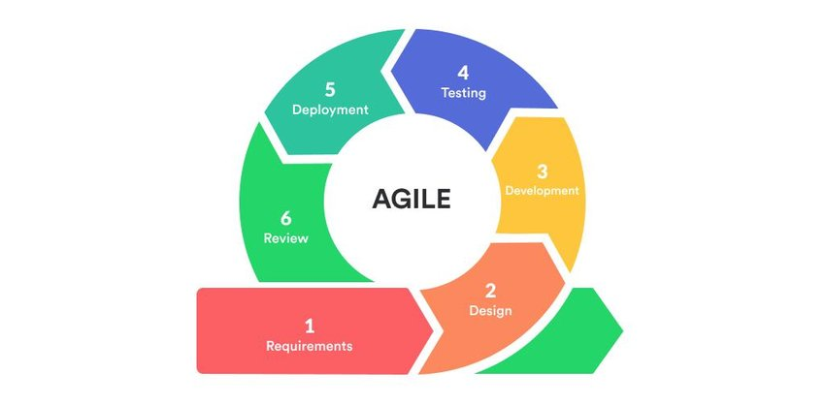

Figure 3.1 Agile Development (Google, 2021)

### Requirements Gathering

Requirements gathering involves generating, analyzing, and documenting the functional and non-functional requirements of the online auction system. The methods used to fully understand customers' demands and include interviews, surveys, workshops and reputable websites. A thorough requirements analysis ensures that the system's objectives, capabilities, and limitations are understood. It aids in establishing user requirements, defining the project's scope and directing the resulting stages of development.

### System Design

The system design phase, where the general architecture of the online auction system is designed, starts once the requirements have been met. The user interfaces, database architecture, and system parts must all be designed. Usually, the detailed design process results in papers that act as a guide for implementation.

### System Development

Here, coding will be carried out in line with rules and specifications to meet the criteria. The programming languages to be used include HTML, CSS and JS, which will be used to program the application due to the fact that the created application is a web based application.

### Testing

In the testing phase of the software development lifecycle, the functionality, performance, and quality of the system will be evaluated. It aims to find software faults, bugs, and errors and make sure the program aligns with the requirements. Testing is important because it aids in identifying and fixing defects early in the development process, aids in confirming the functionality of the system and making sure it behaves as expected and improves the system's dependability and performance.

The testing approach used in this project will be Unit Testing. It is relevant as it enables the validation of individual parts such as transaction processing, smart contracts, or bidding methods. Any bugs or problems can be found and fixed early on in the development process by testing these components individually.

### Deployment

The system is deployed to a production environment after passing testing. This include installing the software, configuring the servers, and setting up the required infrastructure. Data migration and establishing connectivity with external systems, such as payment gateways or delivery suppliers, may also be included in the deployment phase.

### Review

This is the last phase of the Agile method. This process is essential for getting thoughts or views and assessing the features that have been deployed. Interested parties can evaluate the system's compliance with the project's objectives and user needs through routine tests. The development team may make the required adjustments and make sure the system satisfies user demands by adding continuous feedback loops. The users can offer insightful feedback on usability, functionality, and performance, also not forgetting to point out areas that can be improved.

## System Analysis

### Use CASE Diagram

In use case modeling, interactions between system users and the online auction system are identified and defined. It focuses on capturing users and the system. system's functional requirements by highlighting exact actions reactions between users and the system. Use cases give a broad picture identification of the main how the system behaves, helping in the features and user interactions. The features of the system are designed and using them as a foundation, and they also serve to lead the development process.

### ****Sequence Diagram****

Sequence diagrams show how objects interact within a given scenario or use case. They show the sequence of events and the interactions between various components by representing the flow of messages sent and received between objects. By displaying system dynamics, order method calls and responses between objects, sequence diagrams assist in understanding the system dynamics. They also aid in determining how objects interact and are reliant on one another at different stages in a use case.

### ERD Diagram

An Entity Relation Database (ERD) is a model that captures the logical links between the system's entities. It offers a broad overview of the system and a design guide for constructing the actual data structures. To display the relationships (one-to-one, one-to-many, or many-to-many) between entities in the system, an ERD will be implemented.

### Class Diagram

Class diagrams show the classes, along with their attributes, methods, relationships, and associations, to show the system's static structure. They provide examples of the system's objects, their characteristics, and their interactions. Class diagrams show the relationships between classes and the system's structure.

### Activity Diagram

Activity diagrams are useful for comprehending the specific actions of use cases. It is a modeling system that demonstrates the sequence of events and identifies the results. The diagram will be used to display the associated actions and events.

## System Deliverables

### System Proposal

This is a written description of the system design that also includes a statement outlining the system's goal. To fully describe the background details, issues, and solutions that were developed, a proposal is required.

### Administrator Module

This module is only accessible by the admin. As an admin, he or she has the following functions:

1. Responsible for system setup, configuration, and user management.
2. Handles the setup and management of individual auctions.
3. Verifies and validates bids according to auction rules and criteria.
4. Ensures compliance with legal and regulatory requirements.
5. Generates reports and conducts audits for transparency and accountability.

### Bidder Module

Bidders, or vendors can:

1. Takes care of bid verification, bid submitting, and bid monitoring.
2. List an item for sale, specifying the starting price and auction duration.

### User Module

Every registered user in the system has access to this module. The functions here include:

1. Can create or register an account and login/logout.
2. Can view the item's details
3. Place bids on auctioned items

### Auction Creation and Management Module

Authorized users, like administrators, are able to:

1. Create and manage auctions using the auction creation and management module.
2. Has features for managing auction items, setting up auction parameters, and keeping track of the status of the auction.

### Smart Contract Integration Module

Smart contracts are programmable contracts that automatically carry out predefined actions in response to given conditions. By integrating smart contracts into the auction system, this module makes it possible to:

i. Automate procedures like bid validation

ii. Determine the outcome of the auction and stock transfer.

## Tools and Techniques

### Integrated Development Environment (IDE) and Code Editor

In this project, we intend to use Remix as our IDE specifically for the blockchain development of smart contracts. This is because Remix has no setup requirements, promotes a quick development cycle, and has a large selection of plugins with user-friendly GUIs.

Additionally, we also intend to use Visual Studio Code as our source-code editor. The tool is good for editing Solidity smart contracts. Additionally, because to its power and ease of installation across all platforms.

### Blockchain Platform (e.g., Ethereum)

The fundamental infrastructure for developing and deploying smart contracts and carrying out decentralized transactions is provided by a blockchain platform like Ethereum. It makes it possible to store and confirm auction-related data on the blockchain, ensuring security, transparency, and data integrity.

In order to implement blockchain technology into the online auction system and enable safe and unchangable transactions as well as the execution of smart contracts for automated auction procedures, a blockchain platform is needed.

### Version Control System (e.g., Git, GitHub)

A version control system helps in managing and tracking source code changes while facilitating teamwork and providing a history of changes. Git and websites like GitHub enable distributed version control and developer collaboration.

The correct update, branching, and merging of the project's source code are ensured by using a version control system. It makes it possible for several developers to collaborate effectively, undo changes as needed, and keep a complete step by step history of the project's development.

### Solidity Programming Language

A high-level programming language called Solidity was created specifically for creating smart contracts that run on the Ethereum blockchain. It offers the syntax and features needed to identify the characteristics and behavior of smart contracts. Solidity allows developers to implement the reasoning and features of the auction system's smart contracts

It also makes it possible to define auctions, bidding processes, validation guidelines, and other important characteristics specific to the online auction market.

### PHP

Popular blockchain programming language PHP is an open-source, system language. This may be produced using a flexible library, which aids the work of blockchain developers. It can also be built on a range of operating systems.

Importance of using PHP in this project is simplicity in installation and that it is the greatest programming language for smart contracts. In addition, it is compatible with all OS systems.

# System Analysis and Design

### Introduction

This chapter carefully explains the system analysis and design of the implemented system. System analysis, a problem-solving method, breaks down a system into its component parts in order to examine how well each part functions independently and in connection with the others to achieve the goal. The entity-relationship diagram (ERD), use case diagram, sequence diagram, context level diagram, DFD Level 0, DFD Level 1, database schema, UI Wireframes and system architecture are the diagrams created as part of the system analysis. The physical construction of the system, which transforms the requirements into a concrete reality, is the focus of system design. The web application wireframe is depicted in the diagram under the system design.

## System Requirements

Some of the system requirements reviewed in the project include:

### Functional Requirements

1. Authentication Module

The login, forgotten password, and registration pages are located in the authentication module. To successfully log into the application, the user must register their accurate credentials. If the user enters the incorrect information during the login process, they will not be able to access the application. The forgot password page allows users to create new passwords in the event that they forget the ones they used to register with. The user also has an option of signing in using Metamask in case they do not want to use their emails.

1. Administrator Module

The administrator module contains the authentication module and the tables from the database. The administrator can only view the users, sellers, number of bids made, and payment tables. The administrator is able to disable a seller account, only if there are complaints from users in the system.

1. User Module

It encompasses various functionalities related to user registration, authentication, profiles, and interactions within the platform. In the user module, the user can create an account in the registration page. They can also read their details which are stored in the database from the view profile page and can update their profile when need be. The user pays for the item through the application using the digital wallet, which is Metamask.

1. Seller Module

This module includes features like easy auction creation, centralized inventory management, real-time auction monitoring, bid management, transaction and payment management. Sellers can create listings, monitor auctions, manage bids, handle transactions and payments securely. It also aims to provide sellers with effective tools to successfully manage their auction activities within the online platform.

1. Payment Module

This module uses a digital payment method and guarantees safe fund transfers within the blockchain ecosystem. Users who are bidding on items follow a payment option of paying with cryptocurrencies. The module uses encryption techniques to safeguard sensitive data during transmission and storage as it securely gathers and processes payment information. To enable direct and transparent fund transfers between parties, it integrates with blockchain networks or interfaces with digital wallets. Upon the conclusion of the auction, the module also has features for automatically releasing funds to the successful bidder and for verifying payments. In order to increase transparency and auditability within the blockchain system, it also supports transaction tracking and offers a clear payment history.

### Non-functional Requirements

These are the application's non-functional requirements. Rather than discussing the application's features, this section focuses on the application's overall quality.

1. Performance

The system should handle a high volume of concurrent users and transactions efficiently and provide a fast response times for placing bids and updating auction status.

1. Security

A verification email is sent to the user after registration to confirm their identity. As a result, the account becomes active. The user changes the password using their email account during the password-changing process. The user can also login to his or her account using a Metamask account.

1. Reliability

The system should be available and accessible at all times, with minimal downtime. Data integrity and consistency should be maintained throughout.

1. Usability

Intuitive and user-friendly interface for easy navigation and bidding. Clear instructions and guidance for users.

1. Maintainability

Easy maintenance and updates to the system without disrupting the ongoing auctions. Clear documentation and architecture for efficient development and maintenance.

1. Scalability

The system should be capable of accommodating a growing number of auctions and users, and have the ability to handle increased transaction volume and concurrent users.

1. Integration

The system should have seamless integration with external payment systems, digital wallets, and blockchain networks.

## System Analysis Diagrams

Some of the system analysis diagrams include:

### Use Case Diagram

The use case diagram shows the different users, that is the bidders, the sellers and the administrator and their various interactions with the system. The diagram has three actors which are the user, the seller, and the admin. The admin can manage products, manage the departments, manage users, manage bidding and create reports. The bidder can search for a product, view product details, modify bid amount, make a bid for product and edit profile information. The seller can post a product, specify time and price of the bidding, view bidding information and edit profile information. This is shown in

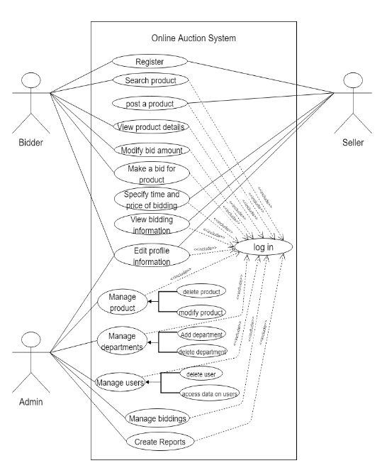

### Sequence Diagram

This sequence diagram demonstrates the basic interactions between the users (bidder, seller and administrator) in the system. The bidder can browse available auctions, place bids, and receive bid confirmations. The seller can create auctions, close auctions, and receive auction closing confirmations. The auction website interacts with the blockchain to perform actions such as retrieving auction details, adding bids, creating auctions, updating bids, and closing auctions. The blockchain records and validates the transactions, returning confirmations to the auction website. This is shown in

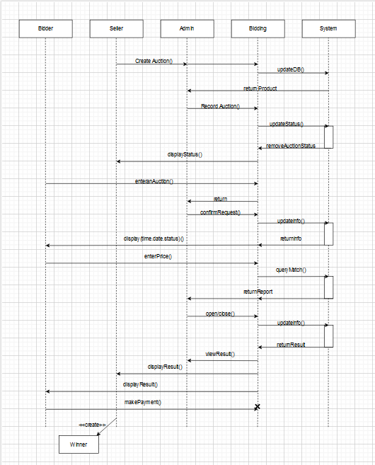

### ERDs

The entity-relationship diagram (ERD), as shown in Figure 4.4, depicts the relationships between the entities (one-to-one, one-to-many, or many-to-many). The ERD diagram has entities which are admin, product, bidder, seller and bidder, etc., which are all related to each other.

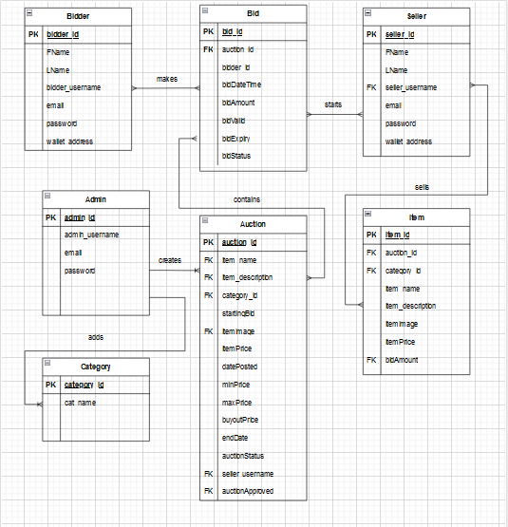

### Context Level Diagram

This provides a high-level view of a system and its interactions with external entities. It shows the system as a single block, surrounded by external entities and their connections. The external entities in this diagram include bidder, seller, admin and biding reports. Below is an example of a context level diagram Figure

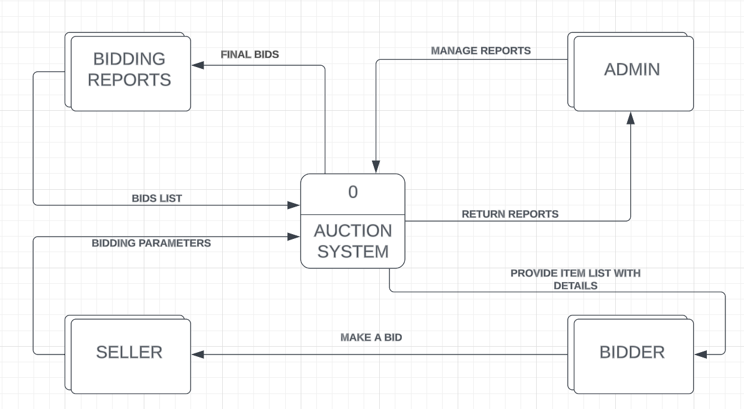

### DFD Level 0

This diagram provides an overview of all the components that interact to form the overall

System. It zooms in on the system and shows major internal processes, data flows, and data stores. This is shown in Figure

### DFD Level 1

## System Design Diagrams

The aim of conducting system design for the developed solution is to primarily focus on how the system will work. Some of the diagrams include wireframes, database schema and system architecture. Each will focus on how to accomplish the objectives of the system.

### Database Schema

The database has categories user, seller, admin, item etc., which store their respective information as show in Table _._

### UI Mockups – Wireframes

1. Bidder Landing Page
2. Login Page
3. Registration Page
4. Reset Password
5. Seller Dashboard
6. Admin Dashboard

### System Architecture

This plan utilizes blockchain to develop a tamper-proof and traceable online auction system. As shown in Figure, it illustrates the physical structure, hardware, and processing methods of the system. It shows data preparation process of requests by the user and by the mechanic.

# System Implementation and Testing

## Introduction

## Description of the Implementation Environment

## Hardware Specification

# References

Andrychowicz et al. (2014, October 22). *Springer Link.* Retrieved from Springer Link Web Site: https://link.springer.com/chapter/10.1007/978-3-319-10512-3_2

Andrychowicz, M. D. (2014). Secure Multiparty Computations on Bitcoin. pp 443-458.

Buterin, V. (2014). A Next Generation Smart Contract and Decentralized Application Platform. *White Paper*, 2-1.

Delmolino, K. A. (2016). *Step by Step Towards Creating a Safe Smart Contract: Lessons and Insights from a Cryptocurrency Lab.* Springer, Berlin, Heidelberg: IEEE.

Federal Trade Commission. (2003, April 30). *Federal Trade Commission*. Retrieved from Federal Trade Commission: https://www.ftc.gov/news-events/news/press-releases/2003/04/internet-auction-fraud-targeted-law-enforcers

Forbes. (2023, February 8). *Forbes*. Retrieved from Forbes Advisor: https://www.forbes.com/advisor/business/ecommerce-statistics/

Grazioli, S., & Jarvenpaa, S. (2000). Perils of Internet fraud: An empirical investigation of deception and trust with experienced Internet consumers. *IEEE Transactions on Systems, Man, and Cybernetics - Part A: Systems and Humans*, 395 - 410.

Grigg, I. (2020). Financial Cryptography: A Blockchain Perspective. In J. Bonneau, A. Miller, J. Clark, A. Narayanan, J. A. Kroll, & E. W. Felten (Eds.). *Bitcoin and Cryptocurrency Technologies*, (pp. 3-24).

Hammi, M. e. (2020). Blockchain Technology for Trustworthy Online Auctions: A Systematic Review. *Computers & Electrical Engineering*.

John Wiley & Sons, H. (2002). Agile Modeling: Effective Practices for Extreme Programming and the Unified Process.

Kokaras, M. &. (2023). The cost of privacy on blockchain: A study on sealed-bid auctions. *Blockchain: Research and Applications, 100133.*

Ladd, B. (2020, November 23). *Forbes*. Retrieved from Council Post: How Social Commerce And Online Auctions Are Set To Revolutionize Retail.: https://www.forbes.com/sites/forbescommunicationscouncil/2020/11/23/how-social-commerce-and-online-auctions-are-set-to-revolutionize-retail/?sh=601346ce30d0

Pinker, E. J. (2003). Managing Online Auctions: Current Business and Research Issues. *Management Science, 49*(11), 1457–1484. Retrieved from http://www.jstor.org/stable/4133995

Taherdoost, H. &. (2023, April 17). *Multidisciplinary Digital Publishing Institute (MDPI).* Retrieved from Blockchain-Based E-Commerce: A Review on Applications and Challenges.: https://doi.org/10.3390/electronics12081889

Times Higher Education. (n.d.). *Times Higher Education*. Retrieved from Times Higher Education: https://www.timeshighereducation.com/hub/p/bringing-increased-security-and-transparency-online-auctions-blockchain-technology

Yli-Huumo, J. K. (2016). Where is Current Research on Blockchain Technology? - A Systematic Review.

# Appendix

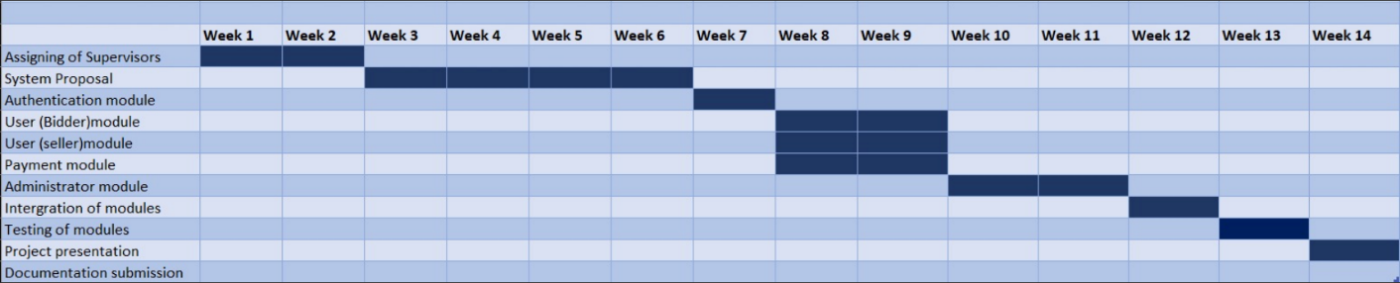**Appendix 1. Gantt Chart**

Appendix 1. Gantt Chart